1. **Used Wireshark to capture DNS Traffic by visiting a http url.**

**Note:** If the website uses DNS over HTTPS or DNS over TLS, the DNS queries are encrypted and you won’t see them as a plain DNS traffic.

**Dns.flags.response==0, Indicates the message is a query. This means the device is asking for the IP address of a service or domain.**

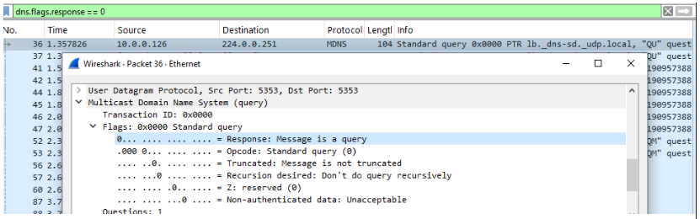

**Dns.flags.response==1, Indicates the message is a response. This means the DNS server is replying with requested information.**

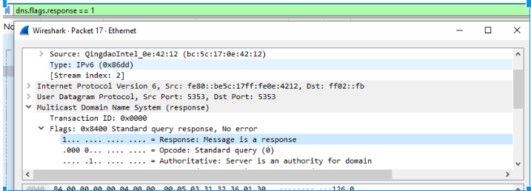

1. **Used Wireshark to capture HTTP GET by visiting a http url.**

**Note**: HTTP POST can be captured if we submit a form via a url using http.

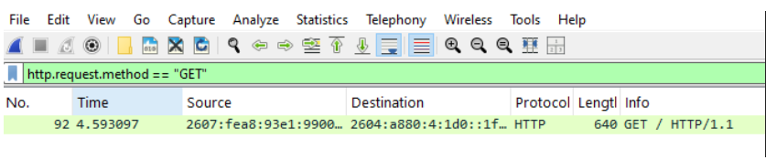

1. **Used Wireshark to capture and filter TCP 3 Way handshake:**



1. **Used Wireshark to capture and filter ICMP Traffic:**

